  **School Of Computer Science Issue Date:** March 26, 2023

**University Of Petroleum and Energy Studies**

 **P.O. Bidholi, Via-Prem Nagar DEHRADUN-248007**

**Major**

**Bachelors of Technology in Computer Science &**

**Engineering Minor**

|  |  |  |  |  |  |  |  |  |  |
| --- | --- | --- | --- | --- | --- | --- | --- | --- | --- |
| **Project Title** | | Solar Panel Maintenance System | | | | | **Mentor Name** | **Project Number** | |
| Sugandha Sharma | |
| **S. No.** | | **Roll Number** | **Branch** | **Name** | **Role** | | | **Signature** |
| 1 | | R177219194 | B. Tech. CSE AI & ML B-6 Sem-VIII | Utkarsh Gupta | Developer & Team Leader | | |  |
| 2 | | R177219206 | B. Tech. CSE AI & ML B-6 Sem-VIII | Aradhya Singh | Developer & Version Control | | |  |
| 3 | | R177219207 | B. Tech. CSE AI & ML B-6 Sem-VIII | Tanu Sharma | Developer & Documentation | | |  |
|  | |  |  |  |  | | |  |

_____________________________________________________ __________________________________________________

|  |  |  |
| --- | --- | --- |
| **Project Mentor** |  | **Head Of Department** |

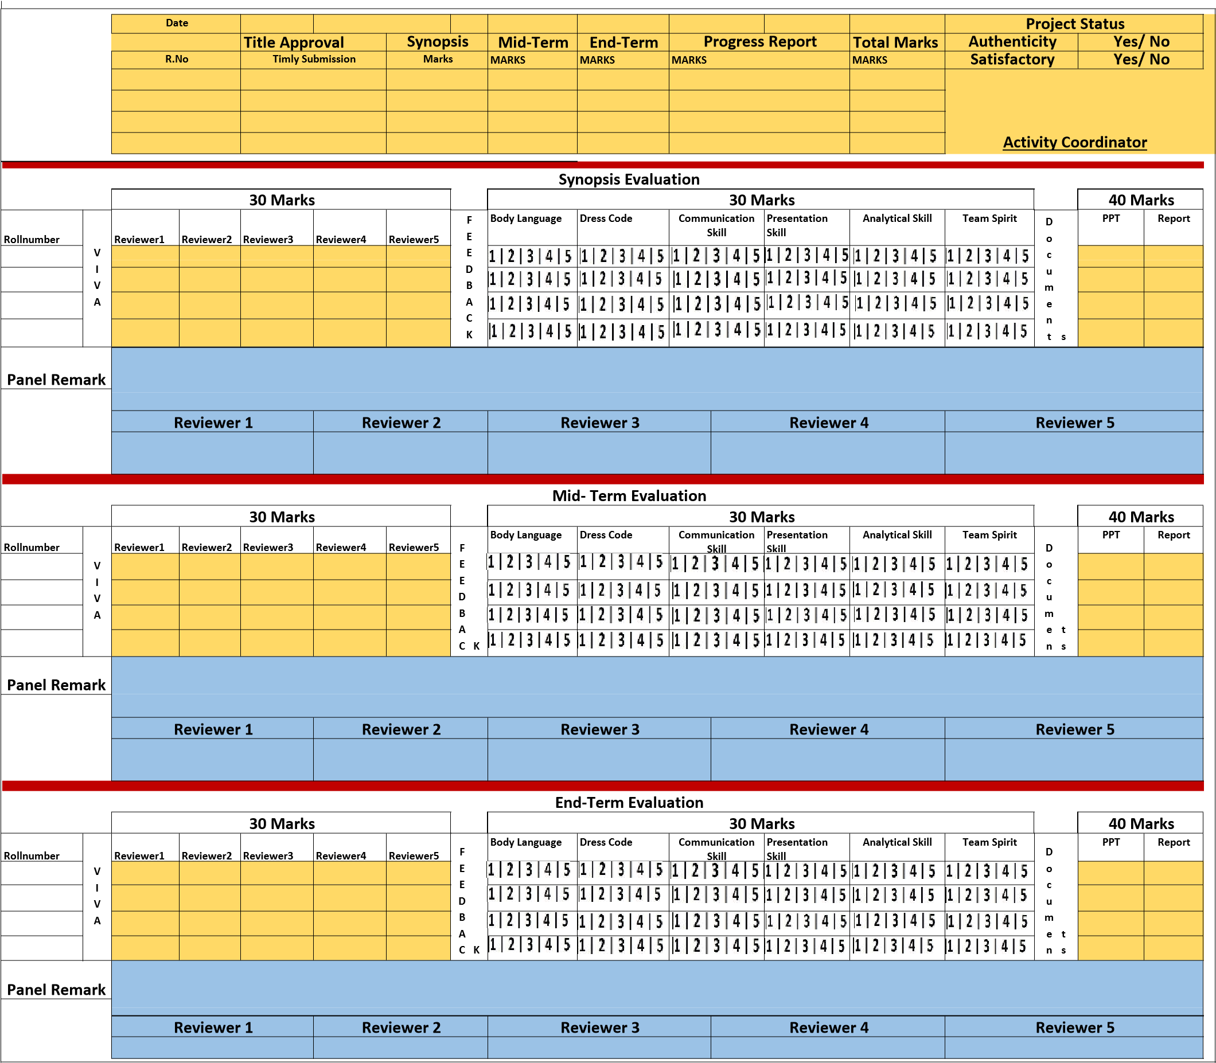

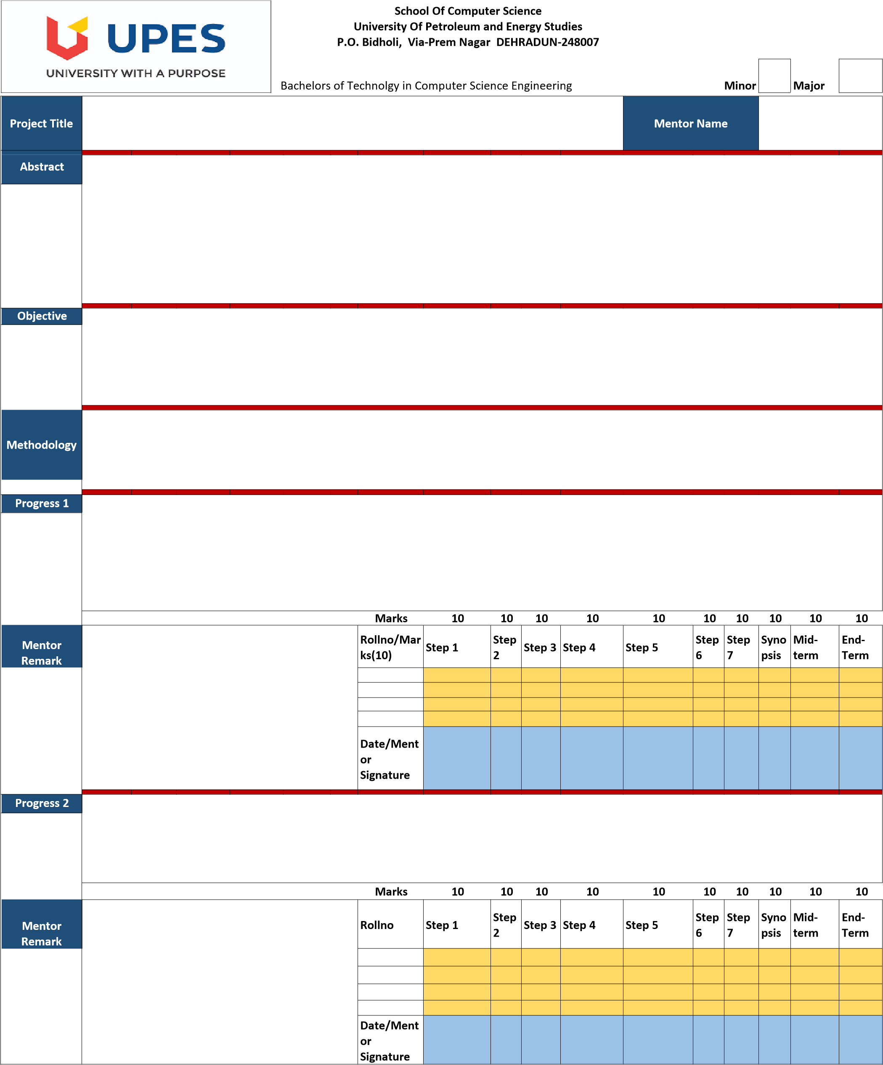

First the AI model for predicting the solar output will be developed and then the prototype of the hardware will be developed.

The objective is to develop a cost efficient and automatic solar panel maintenance system. Thereafter, develop a working prototype hardware of the project to simulate the working in real time environment.

Cost efficient solution for cleaning solar panels automatically without any human interference. The system will be trained to detect whenever a solar panel is generating considerably less solar energy, making the cleaning system active. The system will consist of variety of sensors to get the real time weather information and figure out whether the panel is working efficiently or not. The system will also include a water jet and an air blower to wash and dry out the solar panel.

Solar Panel Maintenance System

* Four machine learning models are trained.
* Hardware is complete and functioning.
* The server and the front end is up and running.
* The data has been collected through the sensor array via an Arduino UNO board.
* Data analysis has been done.
* The prototype of hardware is in final stage of development.

Sugandha Sharma

**Guideline: 1)** A project group can be of maximum 4 members and no alteration in the group member will be entertained later.

**Guideline: 2)** Methodology should have following steps Step1: Literature Review; Step2: Identification of Requirement (Type of Data source, Amount of Data, & Format of Data); Step3: Identification of Algorithm; Step 4: Comparative study; Step5: Design and Development of System/Architecture; Step 6: Implementation; Step7: Results **Guideline:3)** Student should upload softcopies of all the documents (reports and power point presentations) in “Project Directory”, 24 hrs prior to evaluation. **Guideline:4)** Panel member will give feedback to individual on the scale of 1 to 5 and this scale will change for defaulter i.e., 1 to 3 scale.

1: Poor 2: Average 3: Good 4: Excellent 5: Outstanding